**Names:Ishimwe Gulenne GulenneID:23177**

# Course: web technology And internet

* + Mandatory for the users regardless of their positions to have password for (**security)** purposes Candidates can vote for other candidates which are on the positions they are not electing for
  + There shall be a page tha displays candidate.
  + Users shall only register their vote other operations shall be
  + System should ensure that the registered Student ID is an existing valid ID of AUCA students
  + No candidate is allowed to access his opponents account, same for voters (Security)
  + Mandatory for candidates to upload their profiles and their objectives.
  + System should be maintainable for making changes according to the users’ additional requirements (**Maintainability**)
  + Should store the results in the database.
  + System should enable users to search

System should be Available 24hours in 7 days a week (**Availability**)

**Purpose of the project**

Purpose of the project is to provide equal chances of voting for their preferred candidates Auca students to and at the same time making it easy to access voting. Students at Masoro campus had a high chance of voting than the one at Gishushu because it is the place where voting took place.so the system shall solve this problem by provide equal chances of voting for their leader students for both students at Masoro and Gishushu campus.

**scope of the project**

deadlines:-may

**resources used of the project**

* Springboot editor
* Xampp
* intellij

# 7.DATABASEDESIGN

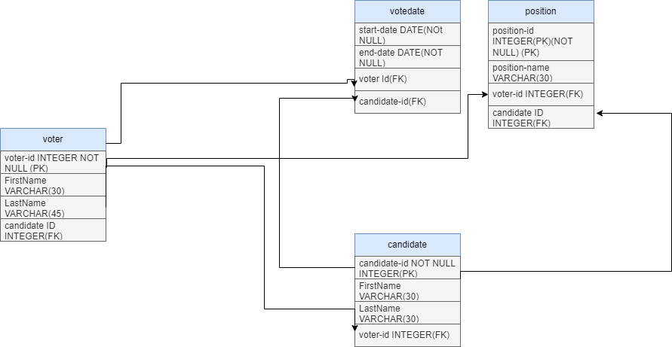

**NB:for the user part he /she can only vote and register their vote but cannot view update or delete these functionality are only and only accessed by the administrator.**

**User documentation**

The homepage is login page if u want to create account click sign up

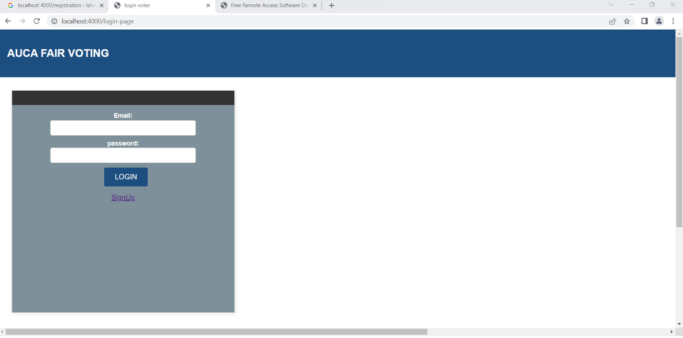

When u click sign up it will take u to the sign up page

**To**

**to**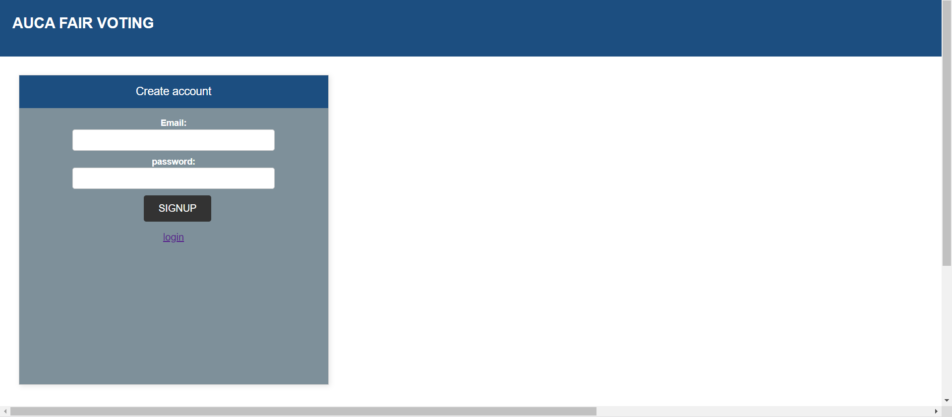

to login as the admin your email should [contain@auca.com](mailto:contain@auca.com) and password should [contain@.but](mailto:contain@.but) for the user you just have to enter normal email and passwords.

After logging in as the user with your credentials you go to the home page

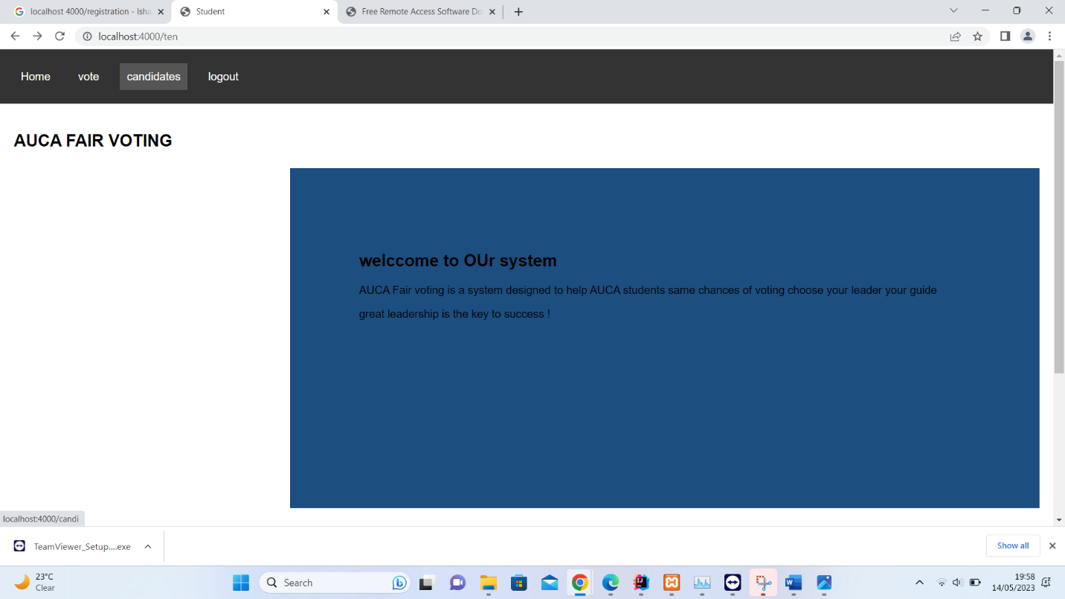

After going to home page if you want to vote for click on candidates it will take you to the candidate page

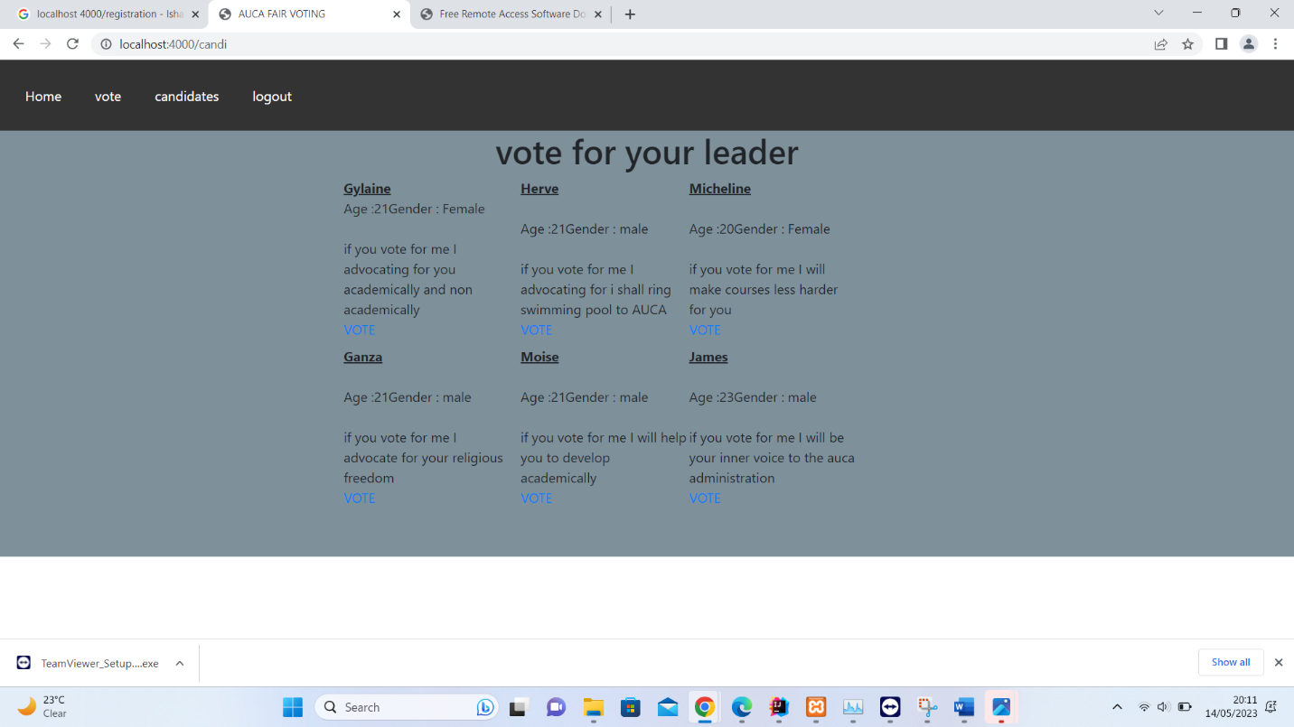

If you want to vote click on vote button

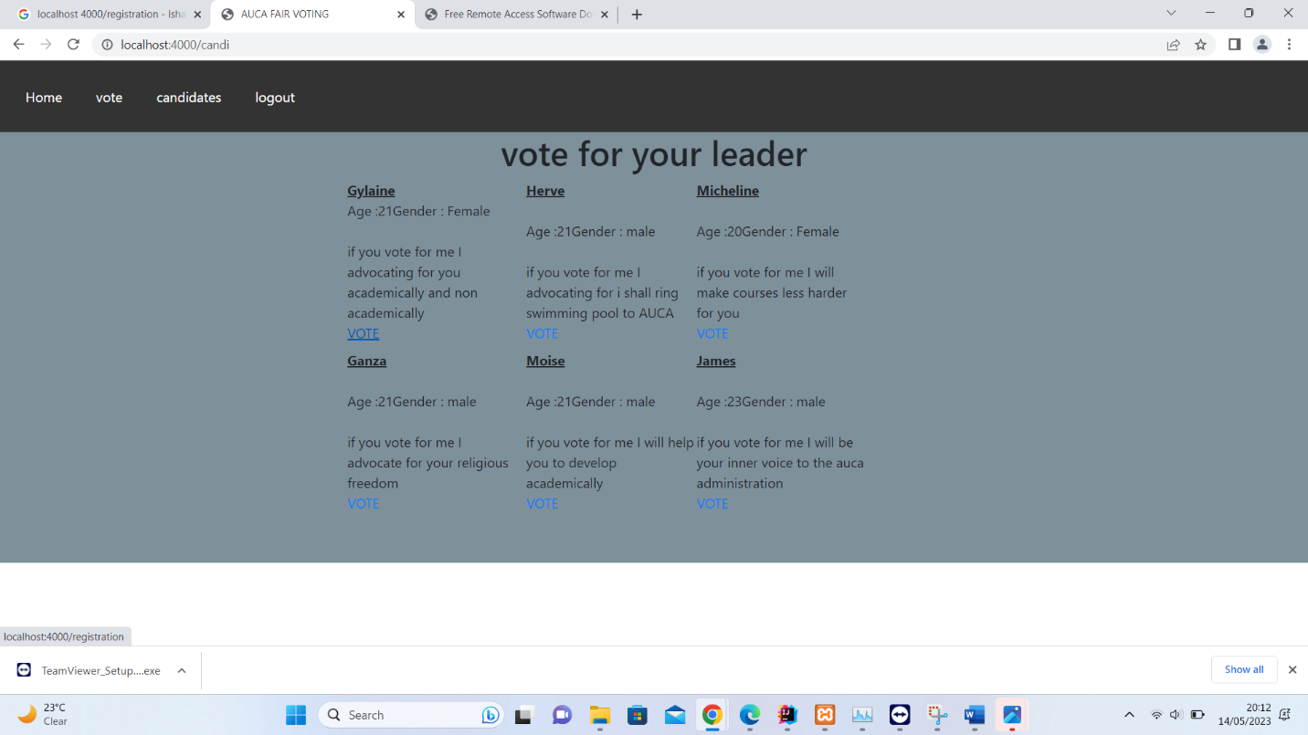

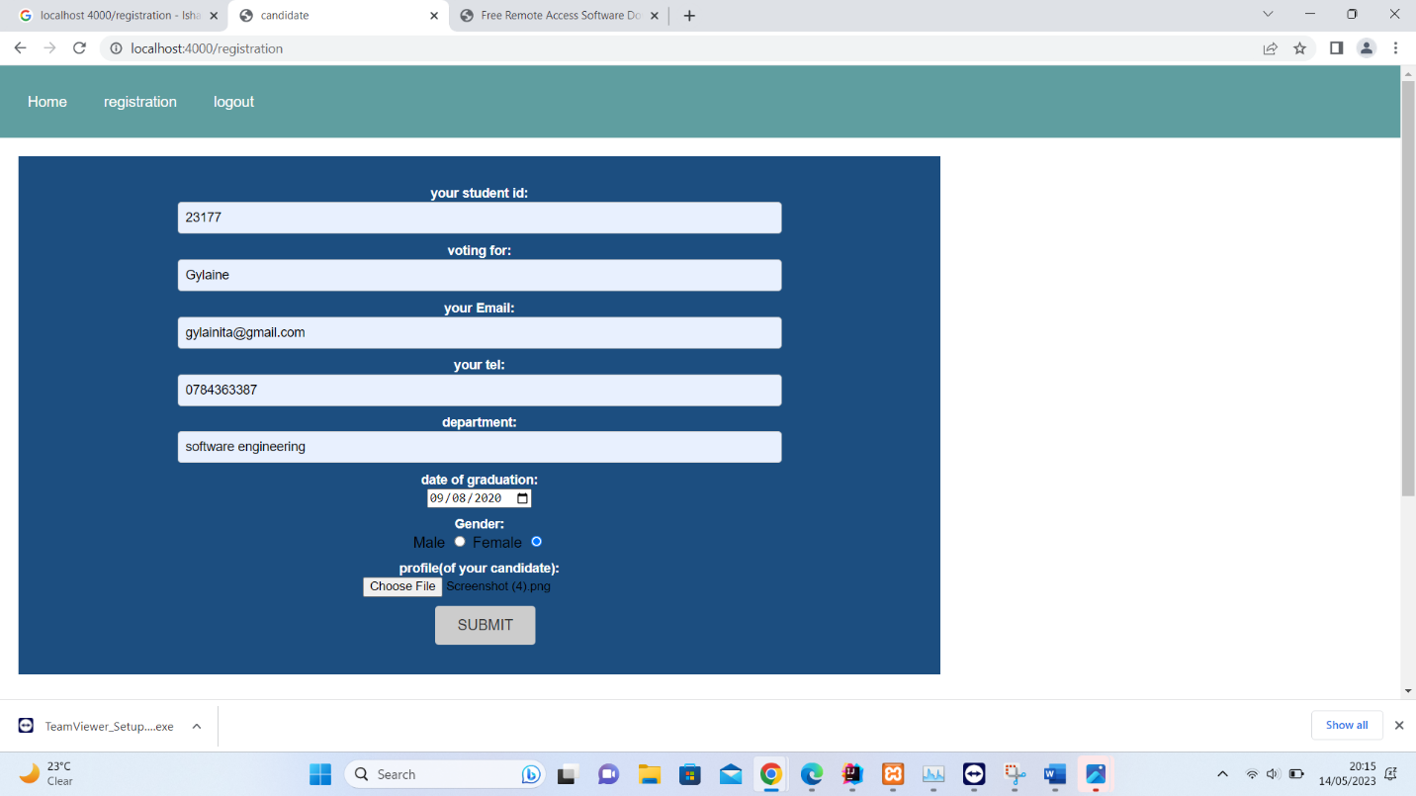

After clicking the vote button then you go the registration page you enter your student id who you are voting for ,your email ,department and graduation date and upload the picture of your candidate after click submit button you will get a message that your vote was registered 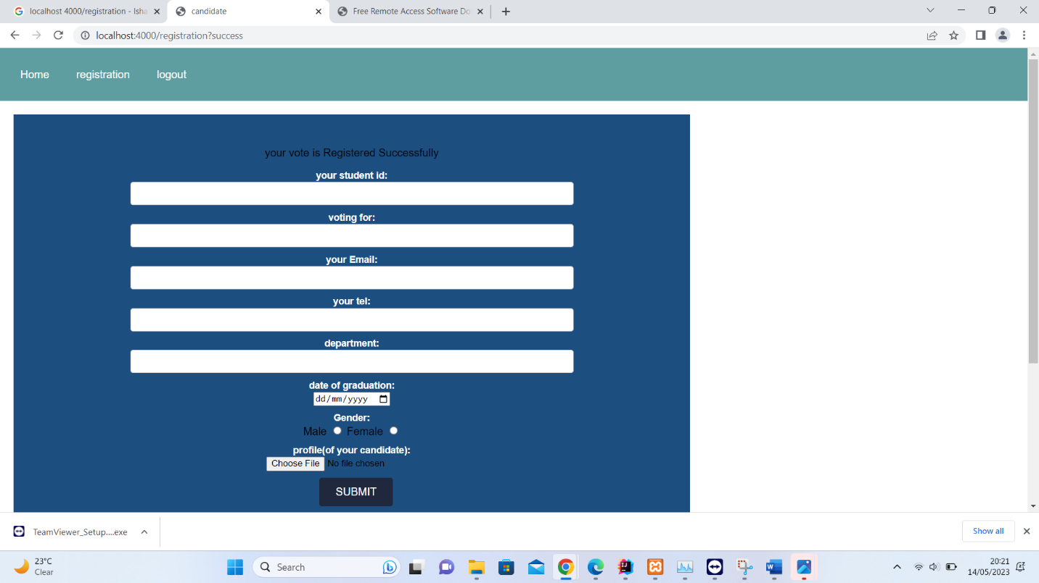

Is the part of the user so now let us go to the admin part who has all permission to update ,delete , register and to search

To login as the admin

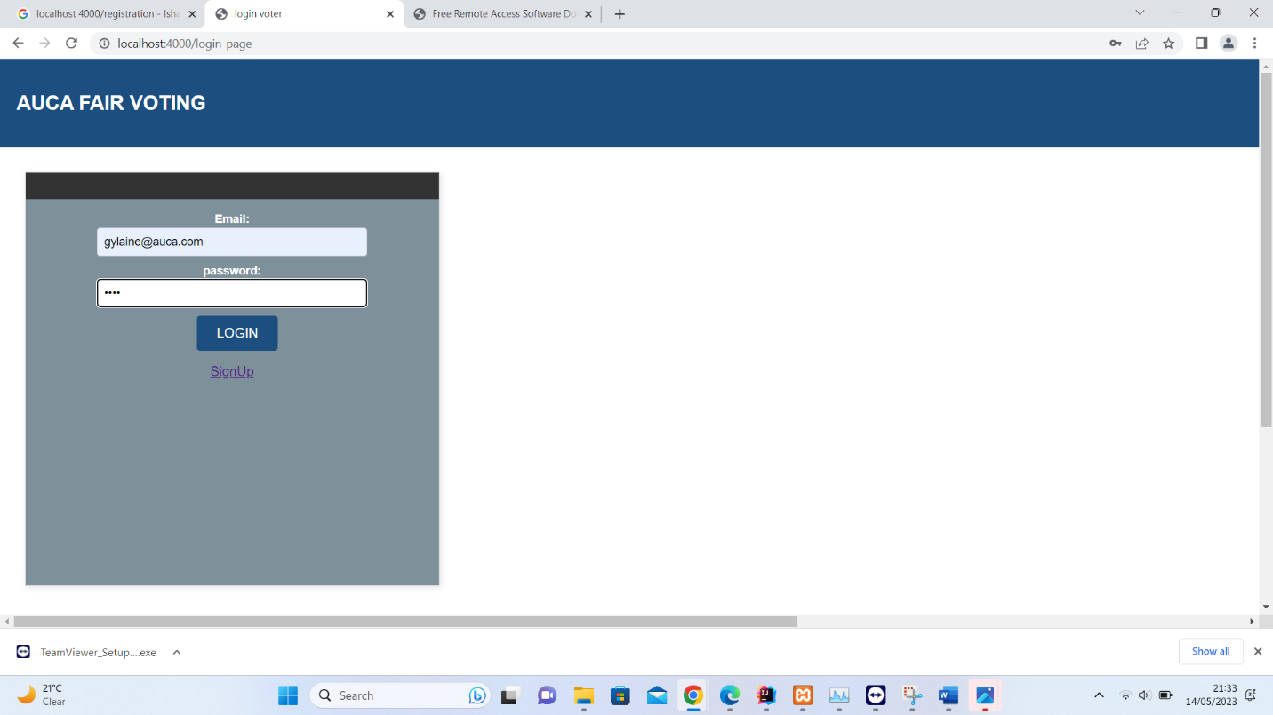\

After login the admin can access all the pages

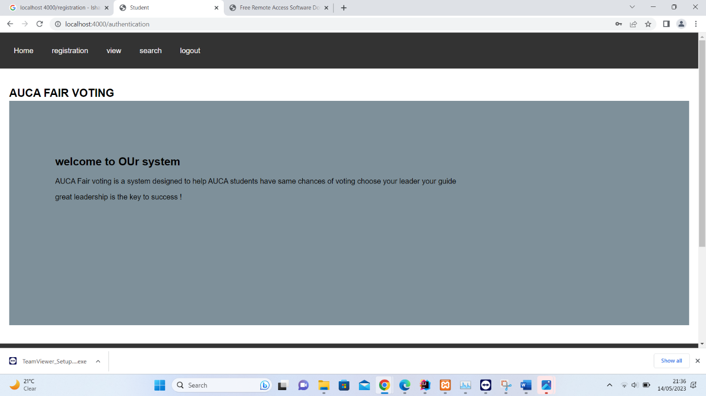

For registration the admin can click on the registration link above.

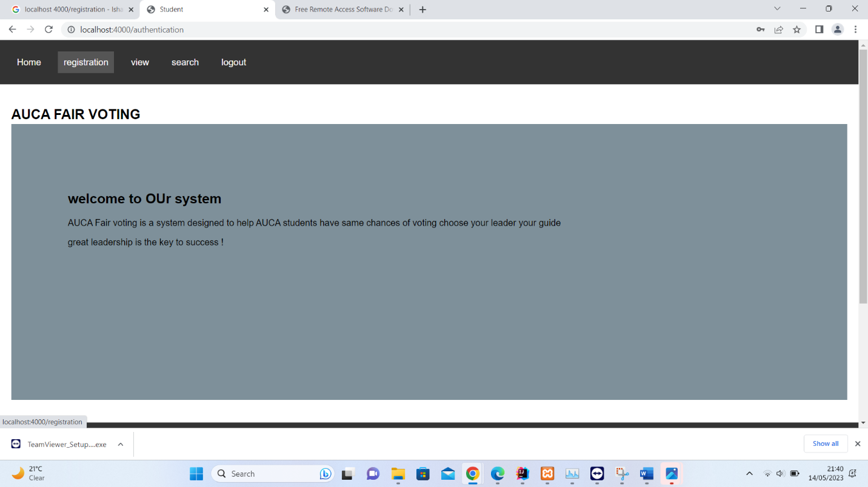

After clicking registartion it will take you to registration page

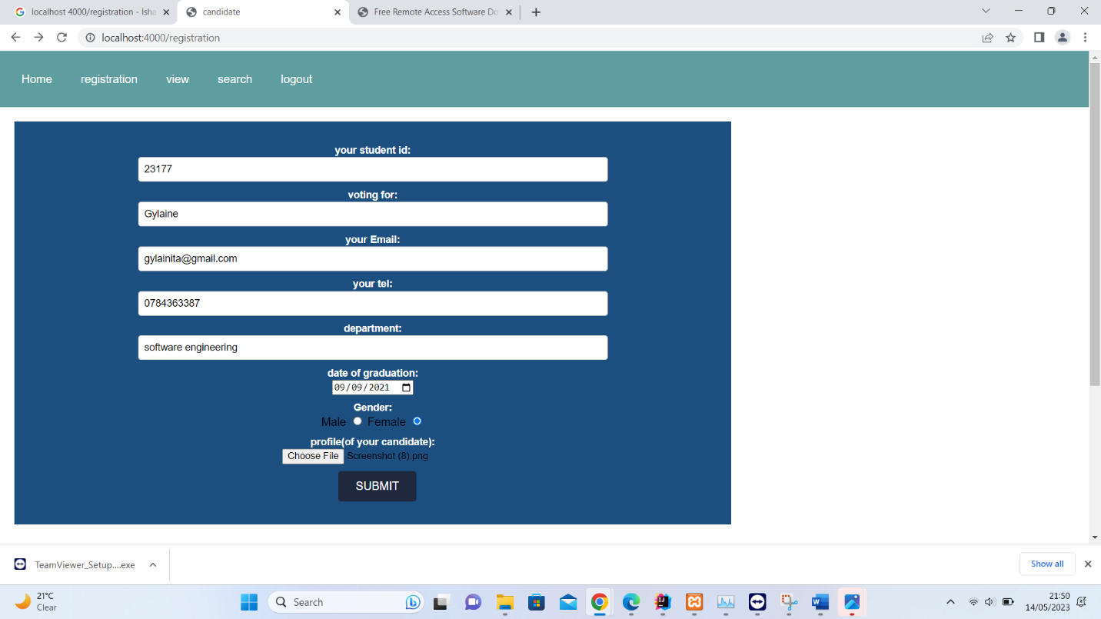

after clicking submit button it will take give you a message



Incase you want to view files click on view

If you want to delete click delete you will receive a message to confirm if you really want to delete

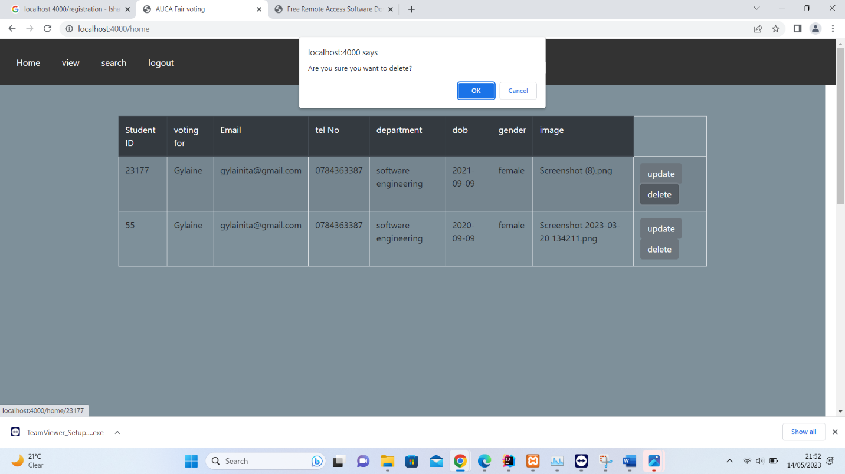

Click ok if you want to delete click ok if it is a mistake click cancel your data will remain.

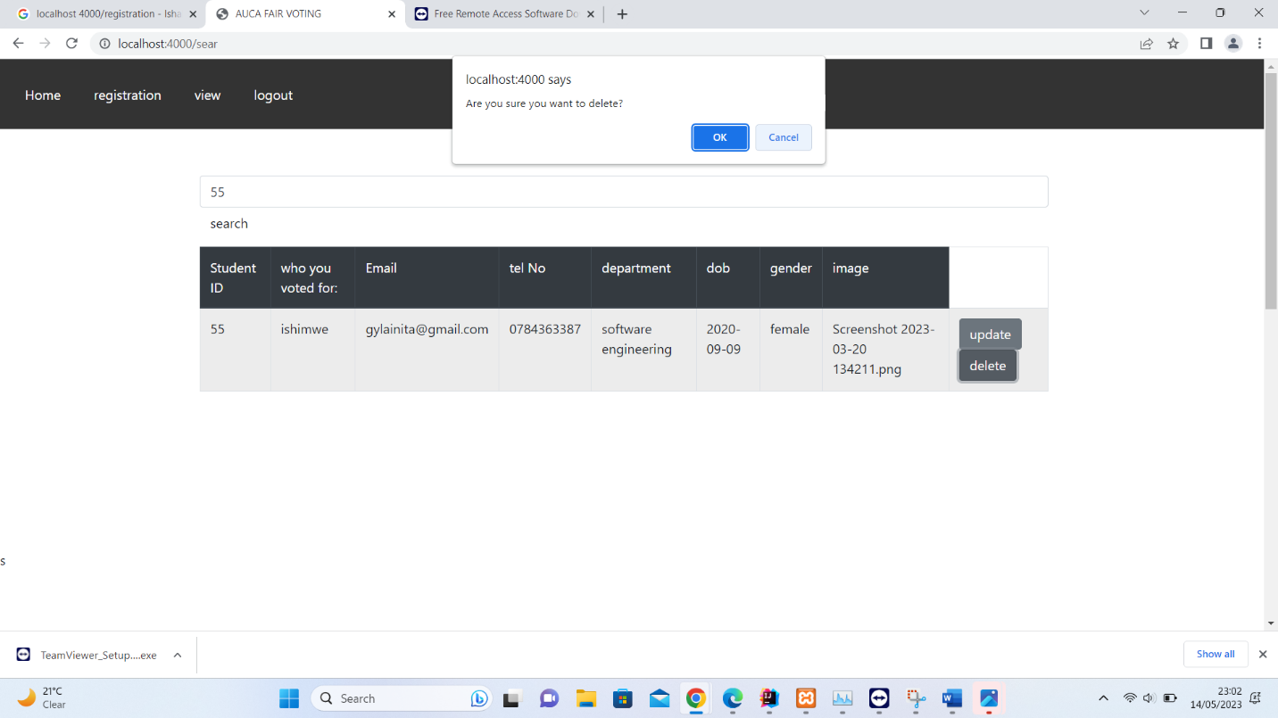

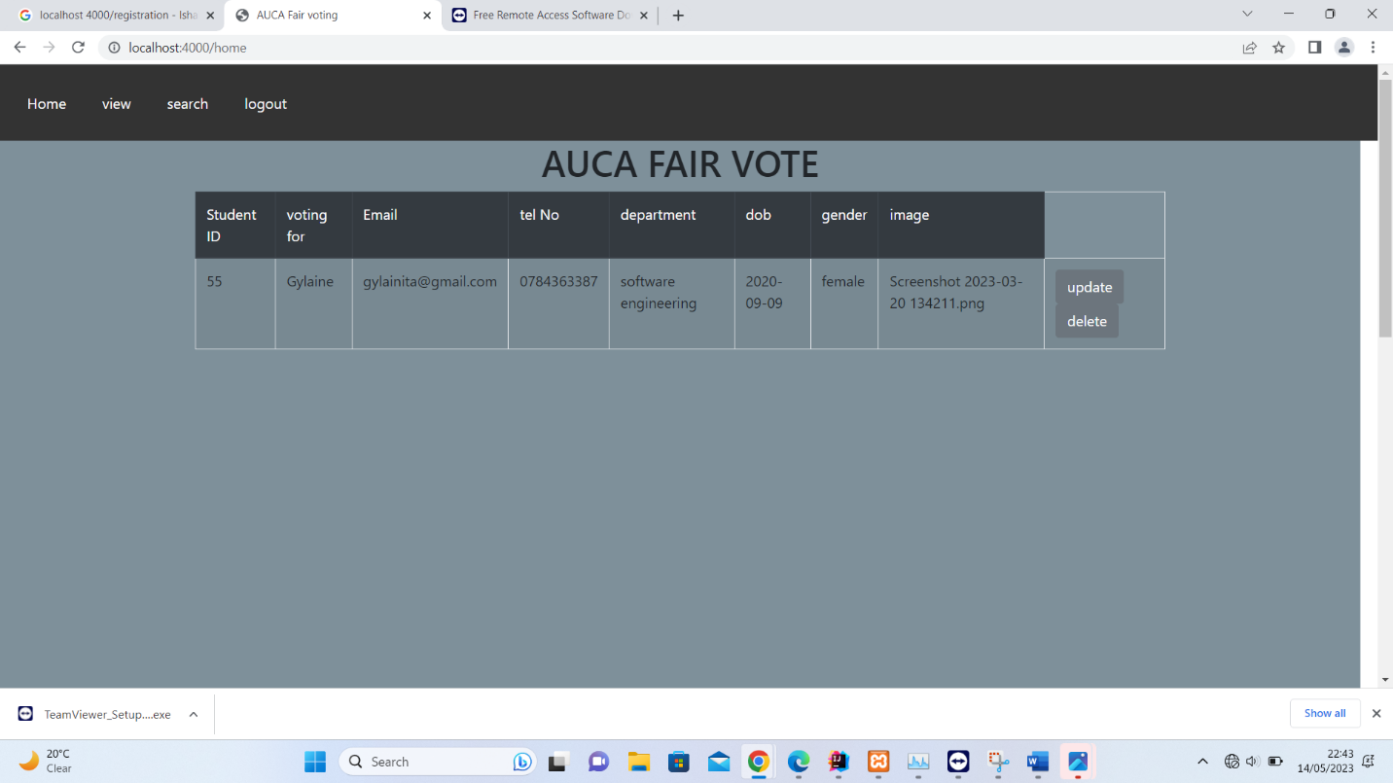

Then your data will be deleted

Updating

Click on update

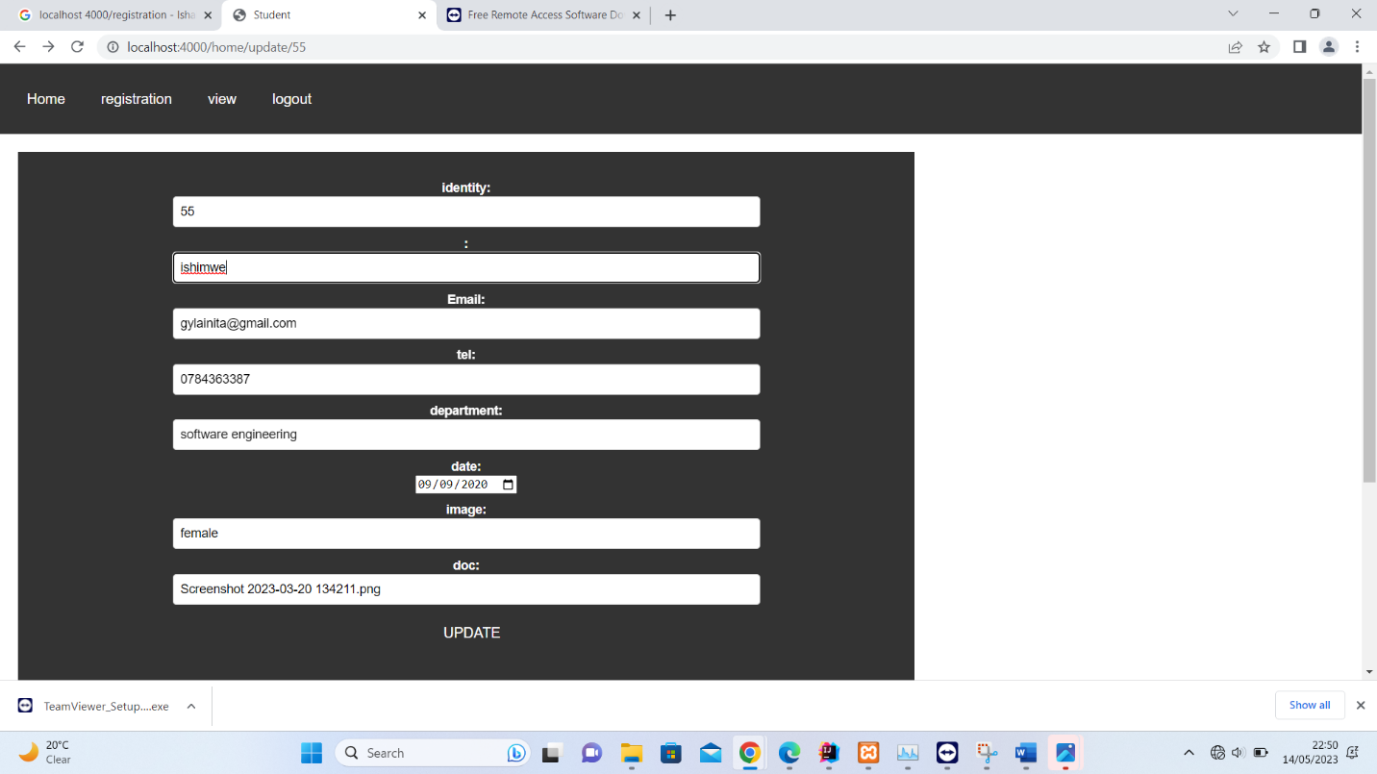

After updating it will take you to the view

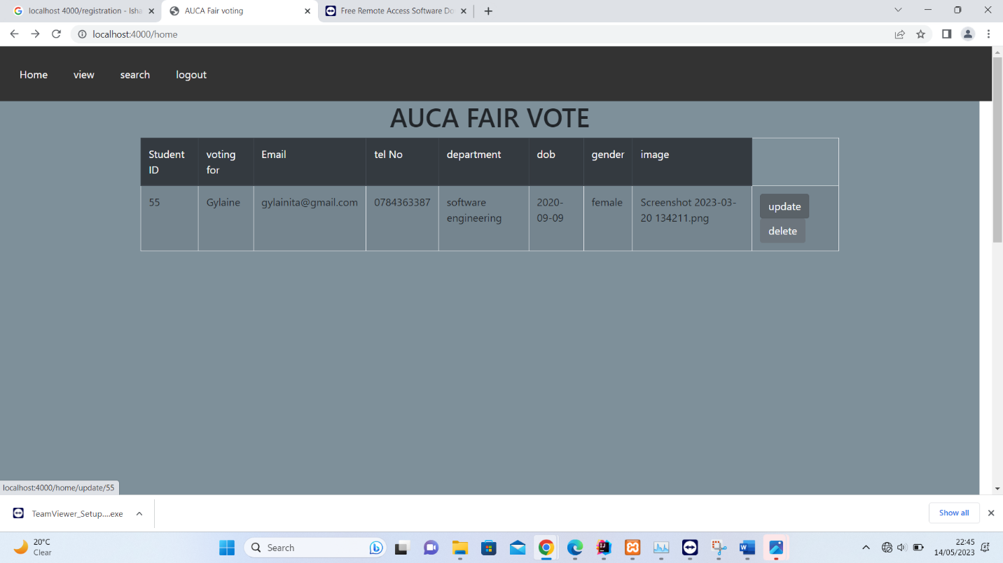

To search for who voted you search by id

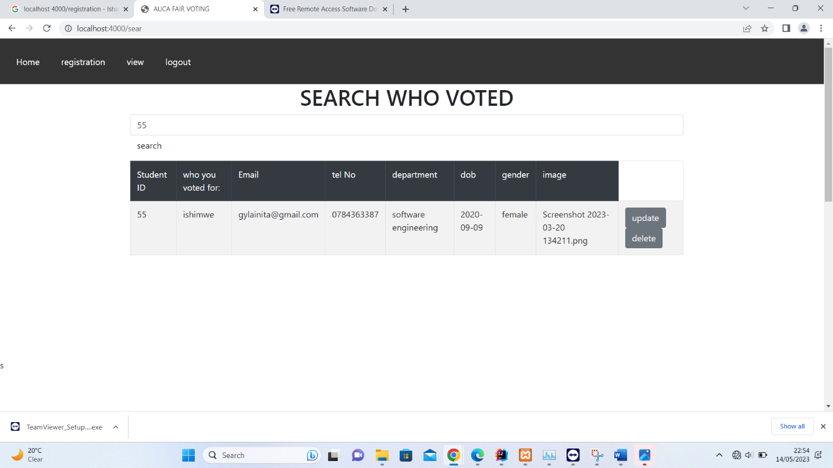

**Technical Documentation**

**Technologies used**

* Spring data Jpa
* Thyme leaf
* Spring security
* Spring web
* MySQL driver

**Controller part used for linking the view and the model part according to the users request**

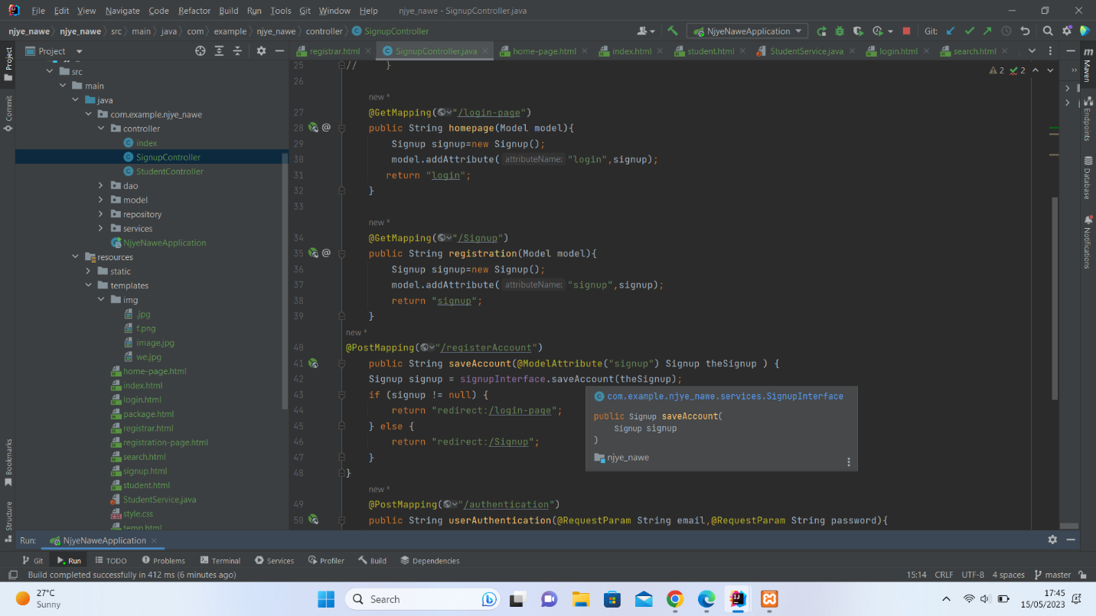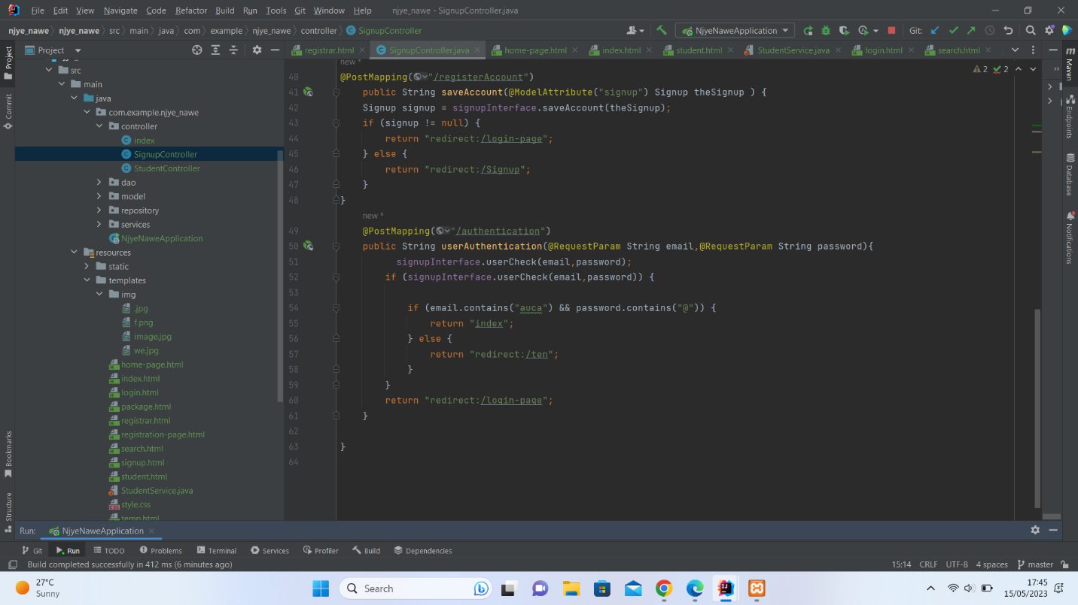

**Model part**

Under The Model Package we create the model. It represents the application data and business logic and encapsulates that data. They will generally consist of POJO.

package com.example.groupspring.model; import jakarta.persistence.*;

import org.springframework.format.annotation.DateTimeFormat; import java.util.Date;

*@Entity*

public class Student {

*@Id*

private String id; private String name; private String email; private String tel; private String dpt;

*@DateTimeFormat*(pattern = "yyyy-MM-dd") private Date dob;

private String image; private String doc; public Student() {

}

public Student(String id, String name, String email, String tel, String dpt, Date dob, String image, String doc) {

this.id = id; this.name = name; this.email = email; this.tel = tel; this.dpt = dpt; this.dob = dob; this.image = image; this.doc = doc;

}

public String getId() { return id;

}

public void setId(String id) { this.id = id;

}

public String getName() { return name;

}

public void setName(String name) { this.name = name;

}

public String getEmail() { return email;

}

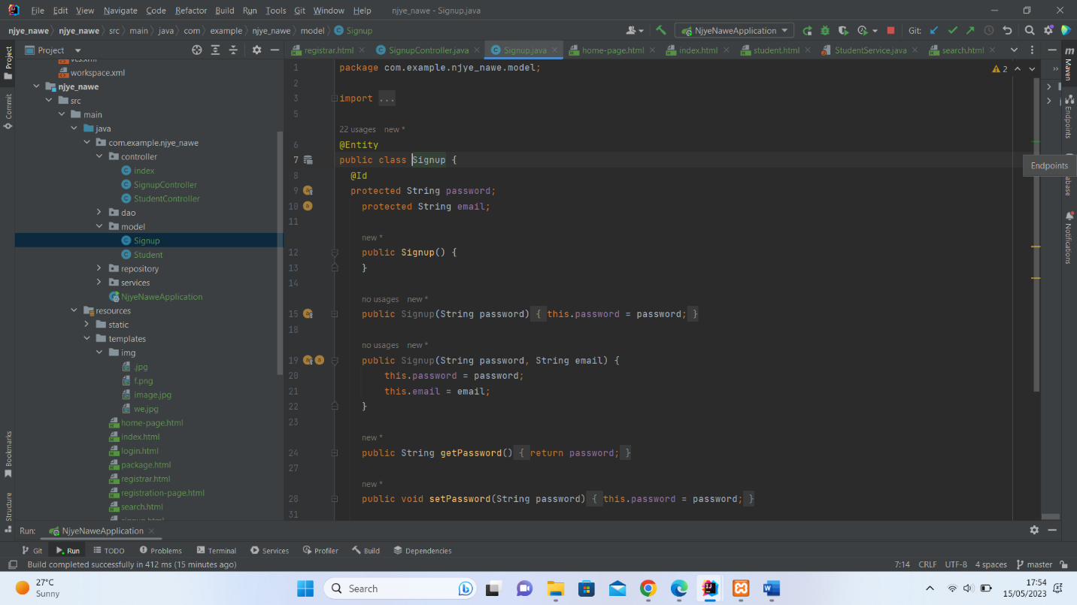

**APPLICATION PROPERTIES**

WHERE WE link our data to the database

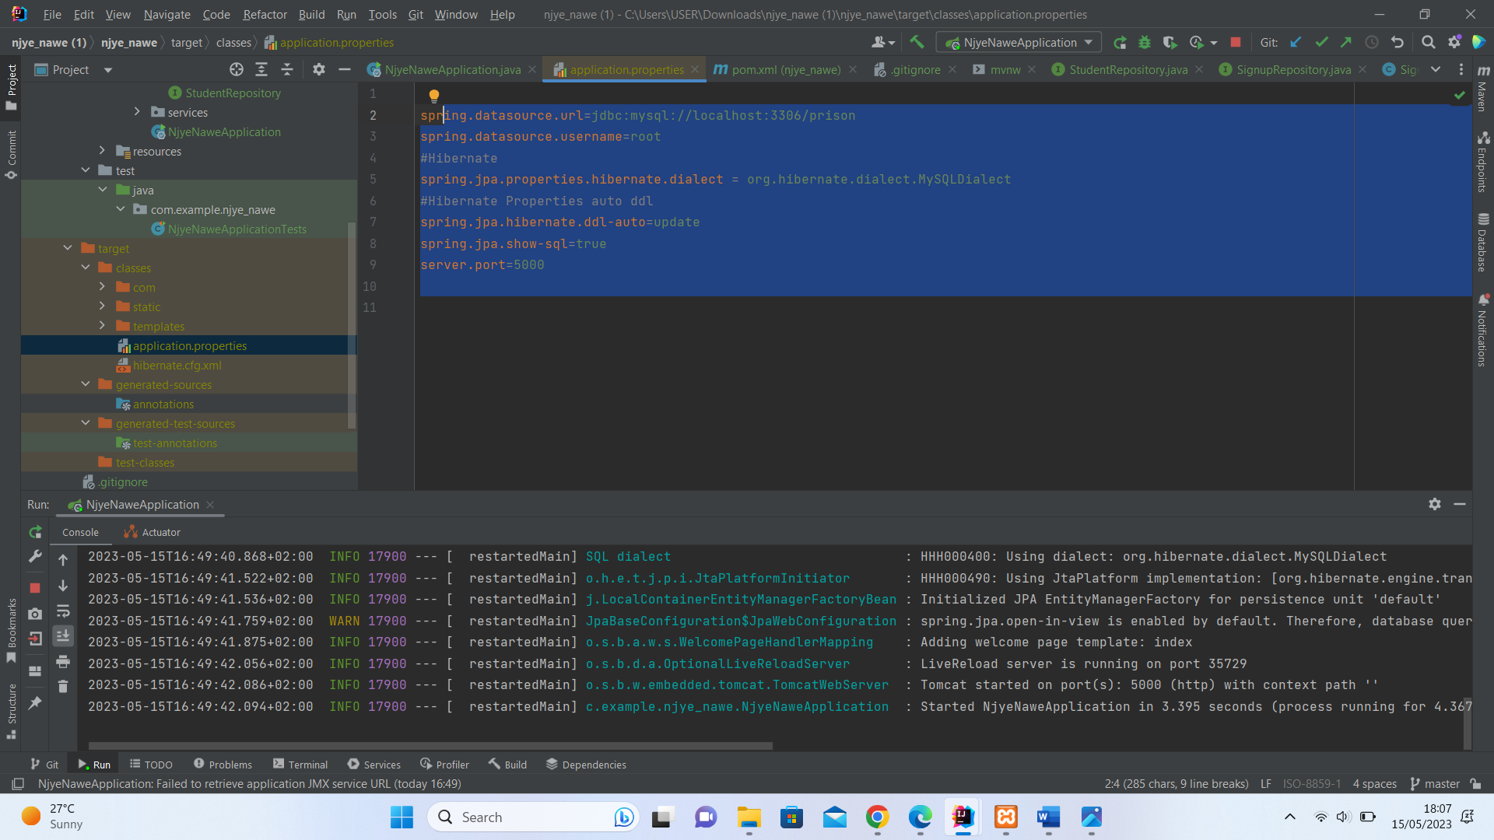

**Service layer**

Where all the CRUD operation take place**.**